Index
- Bean References
- Invoking a Constructor
- @Required Annotation
- Auto-Wiring Beans
- @Autowired
- Bean Scopes
- Bean Initialization and Destruction
- Externalizing Bean Configurations
- Beans by Invoking a Static Factory Method

Bean References:
package com.apress.springrecipes.sequence;
public class SequenceGenerator {
...
private PrefixGenerator prefixGenerator;
public void setPrefixGenerator(PrefixGenerator prefixGenerator) {
this.prefixGenerator = prefixGenerator;
}
public synchronized String getSequence() {
StringBuffer buffer = new StringBuffer();
buffer.append(prefixGenerator.getPrefix());
buffer.append(initial + counter++);
buffer.append(suffix);
return buffer.toString();
}
}

<bean id="sequenceGenerator"
class="com.apress.springrecipes.sequence.SequenceGenerator">
<property name="initial" value="100000" />
<property name="suffix" value="A" />
<property name="prefixGenerator">
<ref bean="datePrefixGenerator" />
</property>
</bean>
<bean id="sequenceGenerator"
class="com.apress.springrecipes.sequence.SequenceGenerator">
...
<property name="prefixGenerator">
<ref local="datePrefixGenerator" />
</property>
</bean>
There is also a convenient shortcut to specify a bean reference in the ref attribute of the <property>
element.
<bean id="sequenceGenerator"
class="com.apress.springrecipes.sequence.SequenceGenerator">
...
<property name="prefixGenerator" ref="datePrefixGenerator" />
</bean>
Spring 2.x provides another convenient shortcut for you to specify bean references. It’s by using the p schema to specify bean references as attributes of the <bean> element. This can shorten the lines of
XML configuration.

<beans xmlns="http://www.springframework.org/schema/beans"
xmlns:xsi="http://www.w3.org/2001/XMLSchema-instance"
xmlns:p="http://www.springframework.org/schema/p"
xsi:schemaLocation="http://www.springframework.org/schema/beans
http://www.springframework.org/schema/beans/spring-beans-3.0.xsd">

<bean id="sequenceGenerator"
class="com.apress.springrecipes.sequence.SequenceGenerator"
p:suffix="A" p:initial="1000000"
p:prefixGenerator-ref="datePrefixGenerator" />
</beans>

Invoking a Constructor:

<bean id="aaa" class="com.apress.springrecipes.shop.Battery">
<constructor-arg value="AAA" />
<constructor-arg value="2.5" />
<property name="rechargeable" value="true" />
</bean>
Constructor Ambiguity:
public class SequenceGenerator {
...
public SequenceGenerator(String prefix, String suffix) {
this.prefix = prefix;
this.suffix = suffix;
}
public SequenceGenerator(String prefix, int initial) {
this.prefix = prefix;
this.initial = initial;
}
}

<bean id="sequenceGenerator"
class="com.apress.springrecipes.sequence.SequenceGenerator">
<constructor-arg type="int" value="100000" />
<constructor-arg type="java.lang.String" value="A" />
<property name="prefix" value="30" />
</bean>

@Required Annotation
@Required
public void setPrefixGenerator(PrefixGenerator prefixGenerator) {
this.prefixGenerator = prefixGenerator;
}
<beans xmlns="http://www.springframework.org/schema/beans"
xmlns:xsi="http://www.w3.org/2001/XMLSchema-instance"
xmlns:context="http://www.springframework.org/schema/context"
xsi:schemaLocation="http://www.springframework.org/schema/beans
http://www.springframework.org/schema/beans/spring-beans-3.0.xsd
http://www.springframework.org/schema/context
http://www.springframework.org/schema/context/spring-context-3.0.xsd">
<context:annotation-config />
...
</beans>

Auto-Wiring Beans
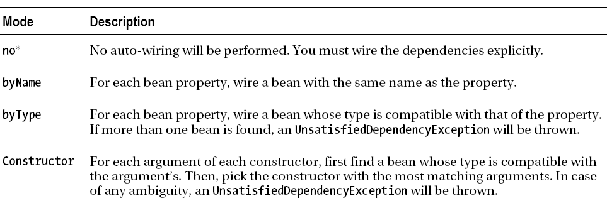

<beans ...>
<bean id="sequenceGenerator" class="com.apress.springrecipes.sequence.SequenceGenerator"
autowire="byType">
<property name="initial" value="100000" />
<property name="suffix" value="A" />
</bean>
<bean id="datePrefixGenerator"
class="com.apress.springrecipes.sequence.DatePrefixGenerator">
<property name="pattern" value="yyyyMMdd" />
</bean>
</beans>
The main problem of auto-wiring by type is that sometimes there will be more than one bean in the IoC container compatible with the target type. In this case, Spring will not be able to decide which bean is most suitable for the property, and hence cannot perform auto-wiring. For example, if you have another prefix generator generating the current year as the prefix, auto-wiring by type will be broken immediately.
<beans ...>
<bean id="sequenceGenerator"
class="com.apress.springrecipes.sequence.SequenceGenerator"
autowire="byType">
<property name="initial" value="100000" />
<property name="suffix" value="A" />
</bean>
<bean id="datePrefixGenerator"
class="com.apress.springrecipes.sequence.DatePrefixGenerator">
<property name="pattern" value="yyyyMMdd" />
</bean>
<bean id="yearPrefixGenerator"
class="com.apress.springrecipes.sequence.DatePrefixGenerator">
<property name="pattern" value="yyyy" />
</bean>
</beans>

Auto-Wiring by Name
Another mode of auto-wiring is byName, which can sometimes resolve the problems of auto-wiring by
type. It works very similarly to byType, but in this case, Spring will attempt to wire a bean whose class
name is the same as the property name, rather than with the compatible type. As the bean name is unique
within a container, auto-wiring by name will not cause ambiguity.
<beans ...>
<bean id="sequenceGenerator"
class="com.apress.springrecipes.sequence.SequenceGenerator"
autowire="byName">
<property name="initial" value="100000" />
<property name="suffix" value="A" />
</bean>
<bean id="prefixGenerator"
class="com.apress.springrecipes.sequence.DatePrefixGenerator">
<property name="pattern" value="yyyyMMdd" />
</bean>
</beans>

Auto-Wiring by Constructor:
The auto-wiring mode constructor works like byType, but it’s rather more complicated. For a bean with a single constructor, Spring will attempt to wire a bean with a compatible type for each constructor
argument. But for a bean with multiple constructors, the process is more complicated. Spring will first attempt to find a bean with a compatible type for each argument of each constructor. Then, it will pick the constructor with the most matching arguments.
Suppose that SequenceGenerator has one default constructor and one constructor with an argument PrefixGenerator.

package com.apress.springenterpriserecipes.sequence;
public class SequenceGenerator {
public SequenceGenerator() {}
public SequenceGenerator(PrefixGenerator prefixGenerator) {
this.prefixGenerator = prefixGenerator;
}
...
}
In this case, the second constructor will be matched and picked because Spring can find a bean whose type is compatible with PrefixGenerator.

<beans ...>
<bean id="sequenceGenerator"
class="com.apress.springrecipes.sequence.SequenceGenerator"
autowire="constructor">
<property name="initial" value="100000" />
<property name="suffix" value="A" />
</bean>
<bean id="datePrefixGenerator"
class="com.apress.springrecipes.sequence.DatePrefixGenerator">
<property name="pattern" value="yyyyMMdd" />
</bean>
</beans>
However, multiple constructors in a class may cause ambiguity in constructor argument matching. The situation may be further complicated if you ask Spring to determine a constructor for you. So, if you use this auto-wiring mode, take great care to avoid ambiguity.

@Autowired
<bean class="org.springframework.beans.factory.annotation.
AutowiredAnnotationBeanPostProcessor" />

Or you can simply include the <context:annotation-config> element in your bean configuration file, and an AutowiredAnnotationBeanPostProcessor instance will automatically get registered.

<beans xmlns="http://www.springframework.org/schema/beans"
xmlns:xsi="http://www.w3.org/2001/XMLSchema-instance"
xmlns:context="http://www.springframework.org/schema/context"
xsi:schemaLocation="http://www.springframework.org/schema/beans
http://www.springframework.org/schema/beans/spring-beans-3.0.xsd
http://www.springframework.org/schema/context
http://www.springframework.org/schema/context/spring-context-3.0.xsd">
<context:annotation-config />
...
</beans>

Note:
By default, all the properties with @Autowired are required. When Spring can’t find a matching bean to wire, it will throw an exception. If you want a certain property to be optional, set the required attribute of @Autowired to false. Then, when Spring can’t find a matching bean, it will leave this property unset.
package com.apress.springrecipes.sequence;
import org.springframework.beans.factory.annotation.Autowired;
public class SequenceGenerator {
...
@Autowired(required = false)
public void setPrefixGenerator(PrefixGenerator prefixGenerator) {
this.prefixGenerator = prefixGenerator;
}
}

Bean Scopes
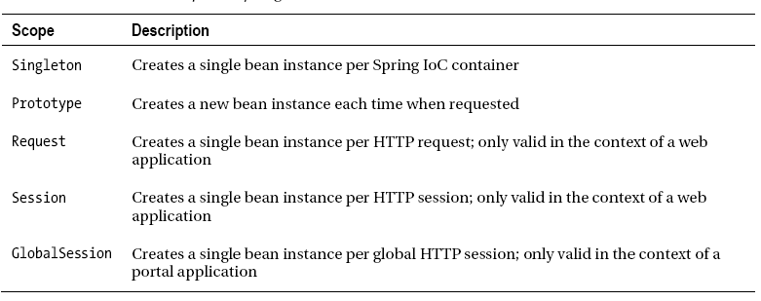

This is because Spring’s default bean scope is singleton, which means Spring creates exactly one
shopping cart instance per IoC container.

<bean id="shoppingCart" class="com.apress.springrecipes.shop.ShoppingCart" scope="singleton" />

Bean Initialization and Destruction

public class Cashier {
private String name;
private String path;
private BufferedWriter writer;
public void setName(String name) {
this.name = name;
}
public void setPath(String path) {
this.path = path;
}
public void openFile() throws IOException {
File logFile = new File(path, name + ".txt");
writer = new BufferedWriter(new OutputStreamWriter(
new FileOutputStream(logFile, true)));
}
public void closeFile() throws IOException {
writer.close();
}
}
<bean id="cashier1" class="com.apress.springrecipes.shop.Cashier"
init-method="openFile" destroy-method="closeFile">
<property name="name" value="cashier1" />
<property name="path" value="c:/cashier" />
</bean>

Externalizing Bean Configurations
the deployment details into a properties file, such as config.properties, in the root of the classpath. Then, define the logging path in this file.
cashier.path=c:/cashier Now, you can use variables of the form ${var} in your bean configuration file. To load the external properties from a properties file and use them to replace the variables, you have to register the bean factory post processor PropertyPlaceholderConfigurer in your application context. You can specify either one properties file in the location property or multiple properties files in the locations property.
<beans ...>
...
<bean class="org.springframework.beans.factory.config.
PropertyPlaceholderConfigurer">
<property name="location">
<value>config.properties</value>
</property>
</bean>
<bean id="cashier1" class="com.apress.springrecipes.shop.Cashier">
<property name="path" value="${cashier.path}" />
</bean>
</beans>

<beans xmlns="http://www.springframework.org/schema/beans"
xmlns:xsi="http://www.w3.org/2001/XMLSchema-instance"
xmlns:context="http://www.springframework.org/schema/context"
xsi:schemaLocation="http://www.springframework.org/schema/beans
http://www.springframework.org/schema/beans/spring-beans-3.0.xsd
http://www.springframework.org/schema/context
http://www.springframework.org/schema/context/spring-context-3.0.xsd">
<context:property-placeholder location="config.properties" />
...
</beans>

Or

if you were to register a Client bean and load its properties from a properties file, you'd first need to register the PropertyPlaceholderConfigurer.
<bean class="org.springframework.beans.factory.config.PropertyPlaceholderConfigurer">
<property name="location">
<value>myconfig.properties</value>
</property>
</bean>

Then, configuring the bean will be achieved by this:
<bean id="client" class="my.package.Client">
<property name="name" value="${name}" />
<property name="lastname" value="${lastname}" />
<property name="country" value="${country}" />
<property name="email" value="${email}" />
</bean>

Beans by Invoking a Static Factory Method:
package com.apress.springrecipes.shop;
public class ProductCreator {
public static Product createProduct(String productId) {
if ("aaa".equals(productId)) {
return new Battery("AAA", 2.5);
} else if ("cdrw".equals(productId)) {
return new Disc("CD-RW", 1.5);
}
throw new IllegalArgumentException("Unknown product");
}
}

To declare a bean created by a static factory method, you specify the class hosting the factory
method in the class attribute and the factory method’s name in the factory-method attribute. Finally,
you pass the method arguments by using the <constructor-arg> elements.
<beans ...>
<bean id="aaa" class="com.apress.springrecipes.shop.ProductCreator"
factory-method="createProduct">
<constructor-arg value="aaa" />
</bean>

